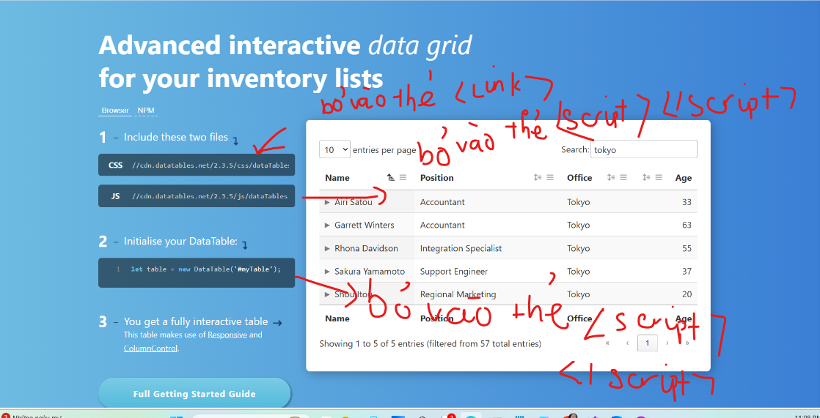

<link href="//cdn.datatables.net/2.3.5/css/dataTables.dataTables.min.css" rel="stylesheet">

<script src="//cdn.datatables.net/2.3.5/js/dataTables.min.js"></script>

<script>
let table = new DataTable('#myTable');

</script>

Views

@model List<TechLaptop.Models.ProductModel>

<a asp-action="Create" asp-controller="Product">Add Product</a>
<table class="table" id="myTable">
<thead>
<tr>
<th scope="col">#</th>
<th scope="col">Product Name</th>
<th scope="col">Product Description</th>
<th scope="col">Product Price</th>
<th scope="col">Product Image</th>
<th scope="col">Product Slug</th>
<th scope="col">Product Category</th>
<th scope="col">Product Brand</th>
<th scope="col">Product Manage</th>
</tr>
</tr>
</thead>
<tbody>
@foreach(var item in Model ){
<tr>
<td ></td>
<td></td>
<td></td>
<td></td>
<td> </td>
<td></td>
<td></td>
<td></td>
<td> </td>
</tr>
}

</tbody>
</table>

<partial name="_Paginate" model="@pager" />

@section Scripts {
<script>
let table = new DataTable('#myTable');

</script>
}
Chức năng Search sản phẩm trong thanh tìm kiếm để tìm kiếm sản phẩm

Controllers

public class ProductController : Controller
{
private readonly DataContext _dataContext;
public ProductController(DataContext _context)
{
_dataContext = _context;
}

[HttpPost] // Chỉ nhận POST requests
[ValidateAntiForgeryToken]
public async Task<IActionResult> Search(string searchTerm)
{

// Th1 : khi sử dụng Linq (Entity Framework Core) kết hợp với Contains thì không phân biệt kí tự hoa hay kí tự thường
var products = await _dataContext.Products // lấy searchTerm chứa trrong Name hoặc Description
.Where(p => p.Name.Contains(searchTerm) || p.Description.Contains(searchTerm))
.ToListAsync();

ViewBag.Keyword = searchTerm;

return View(products);
--------------------------------------------------------------------------------------------------------------------------------------------
//Th2 : chuyển về kí tự hoa hết trước khi kiểm tra
// 1. Chuyển từ khóa tìm kiếm về chữ HOA
string upperSearchTerm = searchTerm.ToUpper();

var products = await _dbContext.Products
// 2. Sử dụng .ToUpper() cho các cột database TRƯỚC KHI gọi Contains()
.Where(p => p.Name.ToUpper().Contains(upperSearchTerm) ||
p.Description.ToUpper().Contains(upperSearchTerm))
.ToListAsync();

// Lưu từ khóa gốc (hoặc từ khóa đã chuyển hoa) sang View
ViewBag.Keyword = searchTerm;

return View(products);

}

}

Views

@model List<TechLaptop.Models.ProductModel>

<div class="col-sm-9 padding-right">
<div class="features_items">
<!--features_items-->
<h2 class="title text-center">Features Items</h2>

@foreach (var item in Model)
{
<div class="col-sm-4">
<div class="product-image-wrapper">
<div class="single-products">
<div class="productinfo text-center">
<img src="~/media/products/@item.Image" alt="@item.Name" width="100%" style="max-height:200px; object-fit:cover;" />
<h2>$@item.Price</h2>
<p>@item.Name </p>
<a class="btn btn-default add-to-cart" asp-action="Add" asp-controller="Cart" asp-route-Id="@item.Id"><i class="fa fa-shopping-cart"></i>Add to cart</a>
</div>
<div class="product-overlay">
<div class="overlay-content">
<h2>$@item.Price</h2>
<p>@item.Name </p>

<a class="btn btn-default add-to-cart" asp-action="Add" asp-controller="Cart" asp-route-Id="@item.Id"><i class="fa fa-shopping-cart"></i>Add to cart</a>
</div>
</div>
</div>
<div class="choose">
<ul class="nav nav-pills nav-justified">
<li><a href="#"><i class="fa fa-plus-square"></i>Add to wishlist</a></li>
<li><a href="#"><i class="fa fa-plus-square"></i>Add to compare</a></li>
</ul>
</div>
</div>
</div>

}

</div><!--features_items-->
</div>

